Time Series Animation

Animations are an interesting way of visualizing time-series data. It distinctively gives the ability to observe how the data evolves. Depending on your data structure, there are two options available to implement time-series animations to your dataset.

1. [Range / Time Slider Plugin]()

2. [Thematic Slider Plugin]()

## Workflow

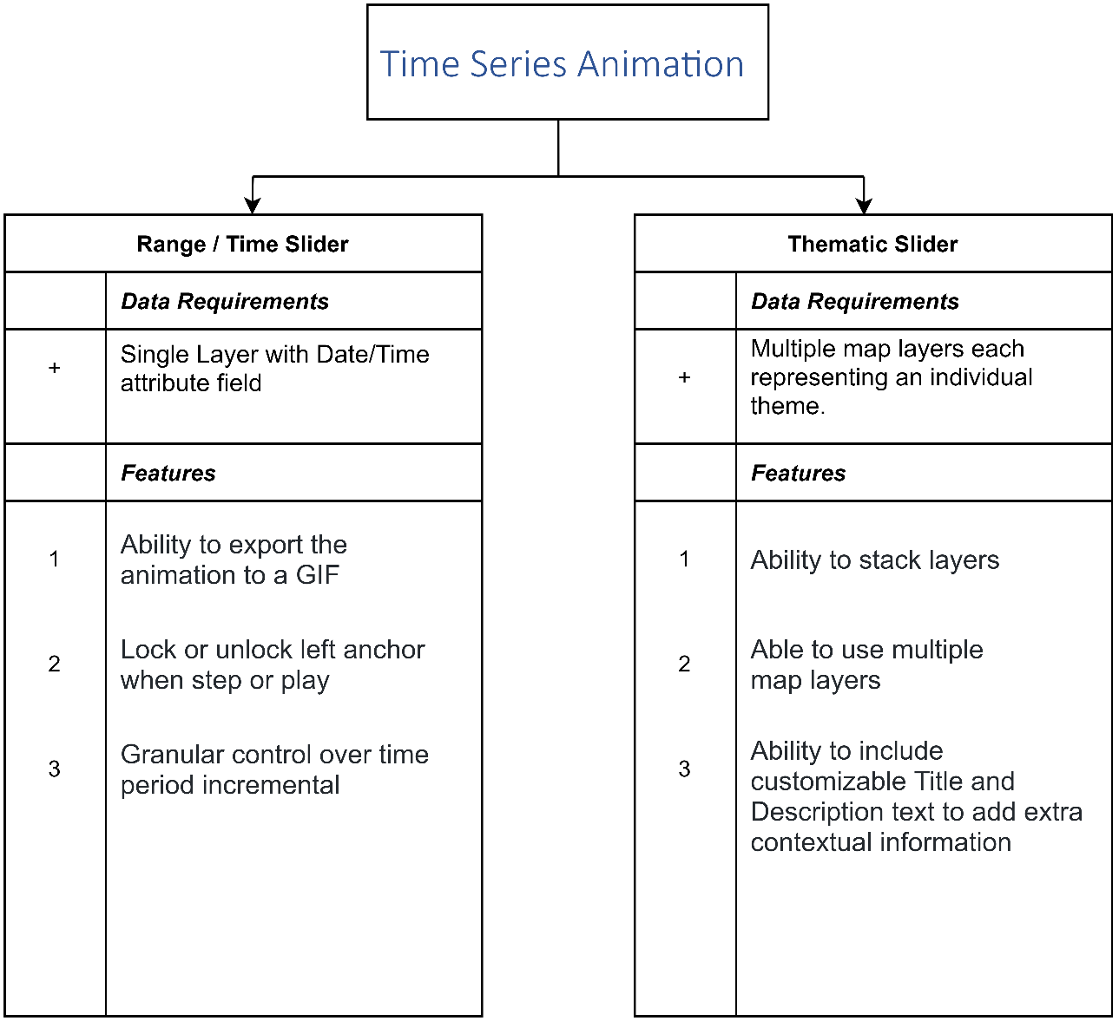

__[Range / Time Slider Plugin]()__

If your data has an attribute where the date is listed then the range/time slider is the best option to be used. The most important requirement is that your date column contains valid timestamp values, otherwise the data may not appear correctly. A column that includes a timestamp could be a date, created at, updated at, posted time, and so on. For example, the following image shows the value of a date column in the Data View.

__[Thematic Slider Plugin]()__

If your dataset consists of multiple raster layers (static maps) as a map service that corresponds to a particular period then the raster time slider is the best option.

# Range Slider/Time Slider

__What is the Range/Time Slider?__

The Range/Time Slider offers a dynamic way to visualize your data. The basic slider is a horizontal bar and has anchors that can be moved to establish the range of the values to be used. To visualize your data as a dynamic range, you can use any layer that contains numeric or date fields.

Once you define the range properties for your layer, an interactive, on-screen slider is used to explore the data through a range/time you customized. Using this plugin, you can control the animation of the data with buttons to play and pause, go to the previous range/time, and go to the next range/time.

**Range Slider**

> Range Slider properties can be set using any numerical or date field stored in the attribute field. For example, a range of values for a particular parameter.

**Time Slider**

> The Time Slider plugin simplifies the visualization of temporal data in your maps. Before adding the Time Slider to your application, you first should understand how it can be configured to correctly display your temporal data.

**What are the advantages of using the Range/Time Slider plugin?**

The Range/Time Slider plugin offers many advantages to both the data contributor and the user.

1. The main advantage to the data contributor when using the Range/Time Slider plugin is the ability to provide Time Series Animation or Range filtering of the data using only one layer.

2. The advantages the Range/Time Slider provides to the user can be summarized in the following points:

- The ability to animation a GIF.

- Granular control over the time increment

- Lock or unlock the anchors when step or play.

## Getting the best out of the Range/Time Slider

The Range/Time Slider is best used in cases where you have a single layer with a numeric / date field. In this regard, you can filter the data using the slider and the results are displayed dynamically on the map.

Take, for example, this map layer [General distribution of humpback whales in the Estuary and Gulf of St. Lawrence](https://gcgeo.gc.ca/geonetwork/metadata/eng/8cf43e2b-f276-4fb7-8d3a-e20fecc618b4) dataset.

If we look at the map service for this dataset, we can see that there are a few fields that can work with the Range/Time Slider Plugin. In this example, the “Year” field was used.

Utilizing the Range/Time Slider together with this rich data, we can dynamically filter the data to narrow results immediately. You can interactively adjust the minimum and maximum values of the displayed range, or move the entire range up and down. The slider and range settings are fully configurable using the Range tab, allowing you to look through the full range extent of your data using logical increments.

By pressing the play button, the map will begin a time-series animation based on the range set. This may be 1-year or 5-year increments. This is a useful ability to determine trends or patterns occurring within the dataset.

https://jolevesq.github.io/contributed-plugins/range-slider/samples/range-slider-index.html?sample=10

## Best Practices

Once you have defined a range for a layer, the range slider appears as an on-screen control along the side of your map or scene.

!!! Tips

Numeric fields containing a timestamp or date field are best used with the time slider. They will be filtered from your selection when using a range.

\*The range slider will automatically snap to whole numbers if the fields driving the range are integers.

## Step By Step Guide

Step 1.

Ensure that the Range/Time Slider Plugin is enabled.

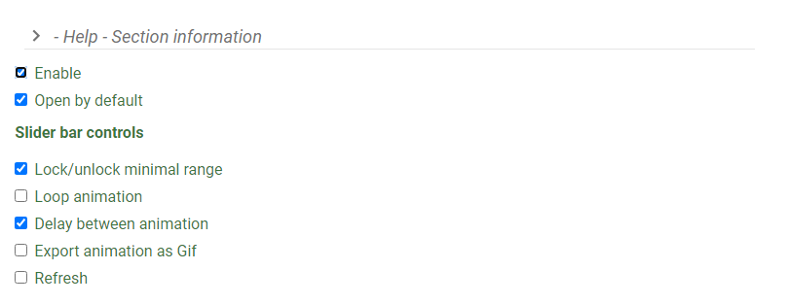

Under Slider bar controls, choose whether you want the slider to do the following:

* Lock/unlock minimal range
* Loop playback.
* Export animation as GIF
* Delay between animation
* Refresh

Choose the Slider Type- Under the Slider Type, select one of the two options, Number or Date. This corresponds to the data attribute that will be used with the plugin.

Set the animation delay. The default is 3sec.

Under layers, select the layer which the plugin will be enabled on.

In this example, the layer id is “Permafrost by ecoprovience” and the field name is “PERMAFROST_PERCENT”.

!!! note

The exact field name must be used, not the alias.

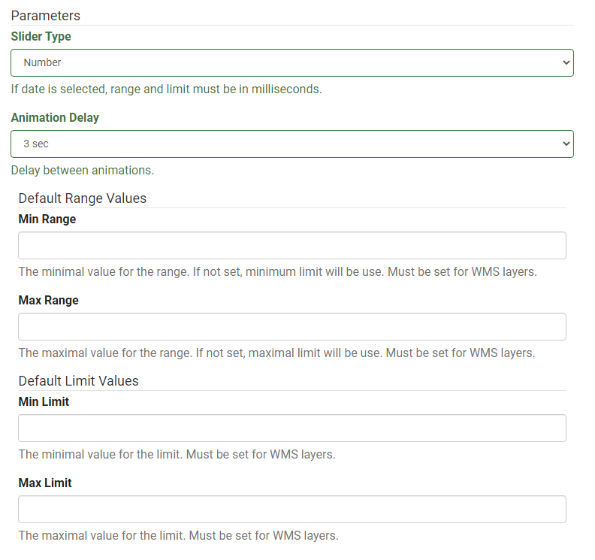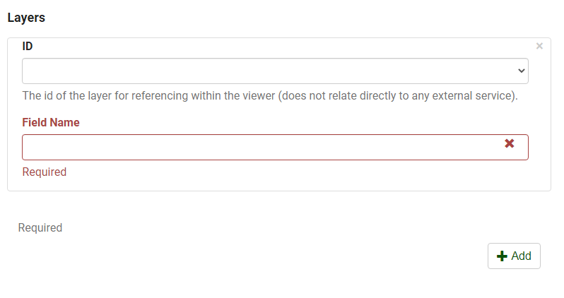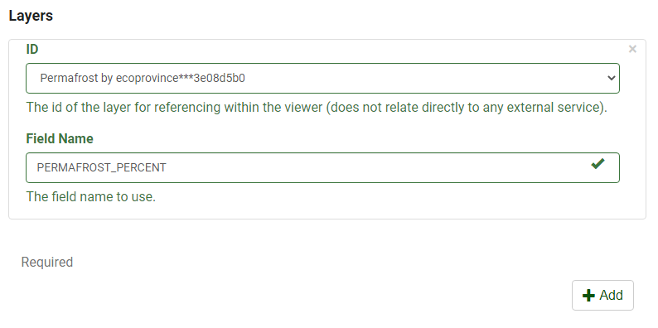

# Use Case Examples

In this example, the Range/Time Slider plugin was used with the [General distribution of humpback whales in the Estuary and Gulf of St. Lawrence]( https://gcgeo.gc.ca/geonetwork/metadata/eng/8cf43e2b-f276-4fb7-8d3a-e20fecc618b4) dataset. The plugin was used with the “YEAR” attribute displaying all the years listed in the field.

https://jolevesq.github.io/contributed-plugins/range-slider/samples/range-slider-index.html?sample=10

!!! tip

Use the anchors on the left and right to set the range of values to be displayed.

In this example, the Range/Time Slider was used with the [Ocean Data Inventory Temperature]( https://gcgeo.gc.ca/geonetwork/metadata/eng/7da1f04f-49b0-4208-a49e-d0597b1f55c6) and [Ocean Data Inventory Salinity]( <https://gcgeo.gc.ca/geonetwork/metadata/eng/7da1f04f-49b0-4208-a49e-d0597b1f55c6>) datasets. The plugin was used with the “COLLECTION_START_DATE” it is interesting to note that both layers share the same field in this example. This made it easier to use the Range/Time Slider plugin with both layers simultaneously.

<https://jolevesq.github.io/contributed-plugins/range-slider/samples/range-slider-index.html?sample=11>

## Step By Step Guide

Step 1.

Ensure that the Thematic Slider Plugin is enabled. 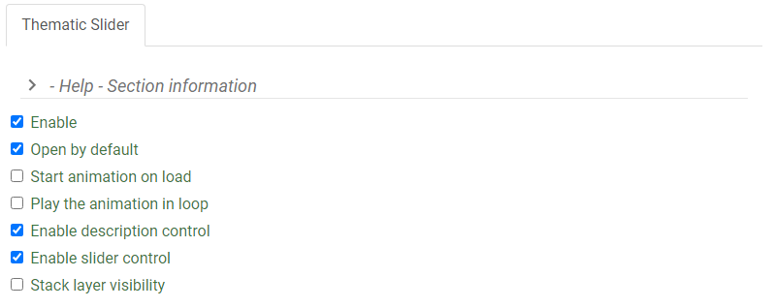

Step 2. Select the options you want the Thematic Slider to do:

Start animation on load

Play the animation on loop

Stack layer visibility

!!! note

By default, the following will be enabled:

Open by default

Enable description control

Enable slider control

Step 3. Under Layers, select the layer which the plugin will be enabled on.

Set the Animation duration, Title for layer animation, and Description for layer animation

Step 4. Optional, Click on the Add Button to create new entries for additional layers.

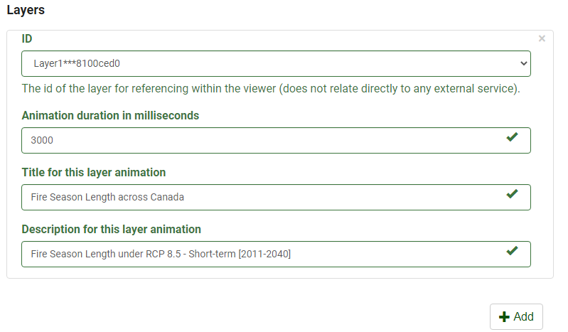

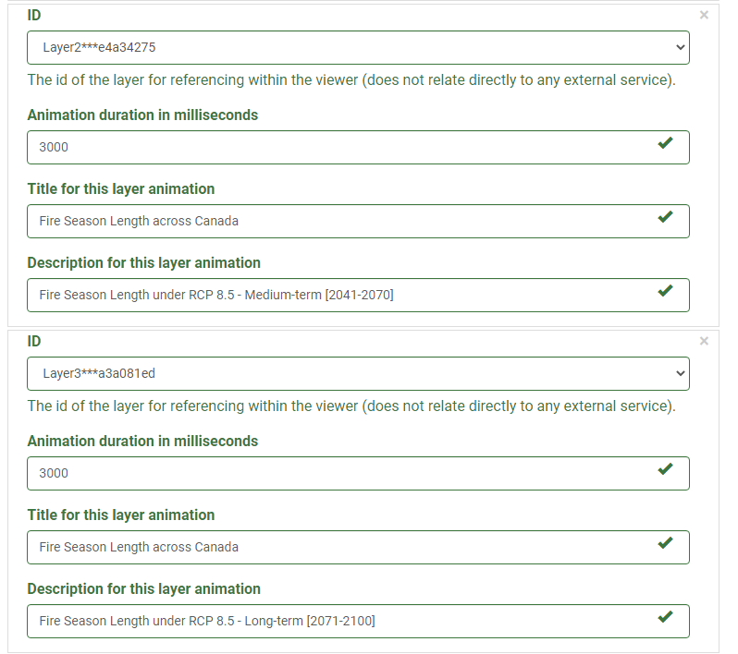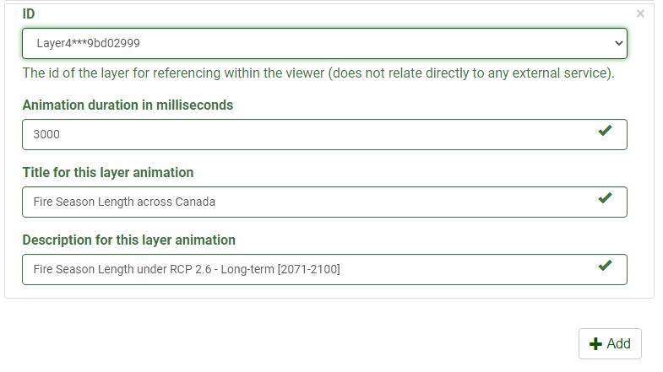

# Draw Toolbar

The Draw Toolbar allows you to interact directly with the map. Functionally, it gives you the ability to create new geometries by drawing them on the map.

The Drawing toolbar contains a collection of icon buttons that allows the user to draw shapes and images in the document.

Some of the features that the Draw Toolbar provides:

__Feature Highlight__

Draw Points / Lines / Polygons

Edit / Erase created objects

Save / Upload Drawing

Includes distance to your lines, perimeter and area to your polygons.

|  |  |  |
| --- | --- | --- |
| Button | Name | Function |
|  | New Marker | Draws a marker point |
|  | New Line | Draws a line and includes the distance of the line |
|  | New Polygon | Draws a polygon and includes the area and perimeter of the shape |
|  | Color Picker | Allows you to select different colors |
|  | Edit Vertices | Allows you to edit the vertices of the selected line, polygon, or curve |
|  | Toggle text | Shows or hides the text. On by default |
|  | Erase | Erase selected features |
|  | Save | Saves graphics to file |
|  | Upload | Uploads saved graphic file to the map |

# Area of Interest

The Area of Interest plugin allows specific geographic extents on a map to be easily displayed. Using the Area of Interest plugin simply zooms to the specified area giving the user the ability to learn more about that area / bringing it into focus.

The world is full of information, which means highlighting necessary information/locations on the map without distracting the user can be a huge task. Utilizing the Area of Interest plugin, the results are a cleaner look that makes it easier to see helpful and actionable information. The highest places with the highest concentration of value to the user are brought forth to the user as they explore the map.

__Feature Highlight__

Directly points users to the extent indicated

Ability to customize the thumbnail of each Area of Interest

## Use Case Examples

The Area of Interest plugin can be accessed using the Menu tab to the left of the Layers information box. After clicking on the Menu bar, scroll to the bottom where you will notice the plugins section. Simply click on the Area of Interest plugin to enable it.

# Coordinates Info

The coordinates Info plugin provides the geographic coordinates of any point on the map.

__Feature Highlight__

Displays:

Geographic Coordinates

UTM Coordinates

National Topographic System Index Maps (NTS)

Provides elevation at any point

(Show Image)

## Use Case Examples

The Coordinates Info plugin can be accessed using the Menu tab to the left of the Layers information box. After clicking on the Menu bar, scroll to the bottom where you will notice the plugins section. Simply click on the Coordinates Info plugin to enable it.